Lab: Data Types, Variables and Simple Operations
Submit your solutions here: https://alpha.judge.softuni.org/contests/data-types-variables-and-simple-operations-lab/5303

Console program "Hello SoftUni"
Write a console Python program that prints the text "Hello SoftUni".
- Start PyCharm
- Create new project: New Project:
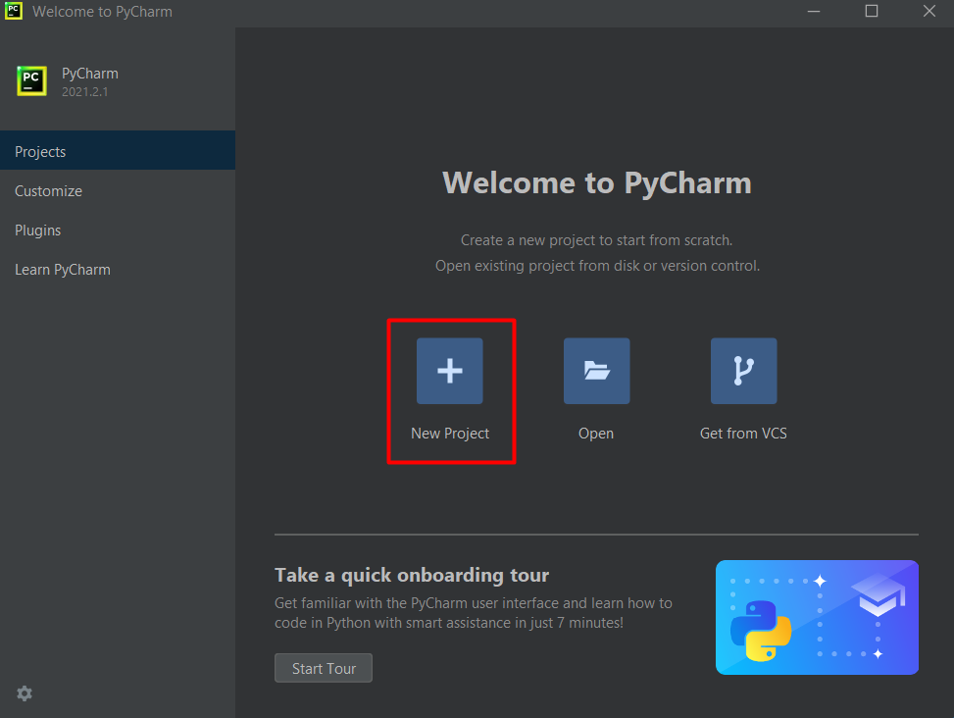
- Set an appropriate name and directory, where you want to create your project:
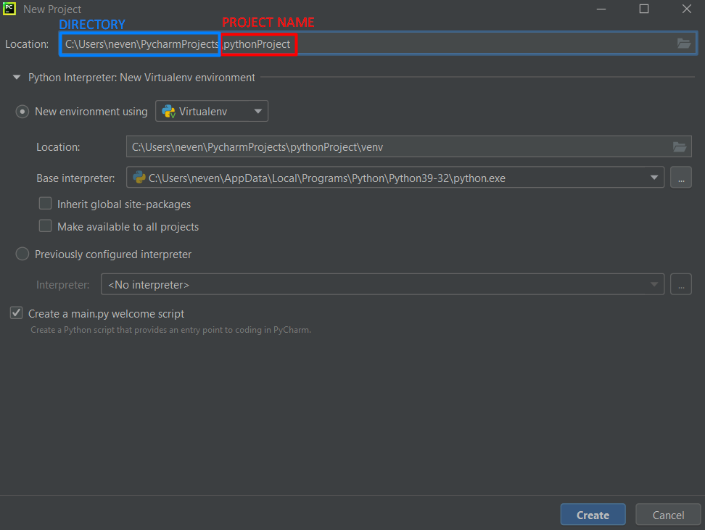
- Create a new file: Right-click on the project name → New → Python File:
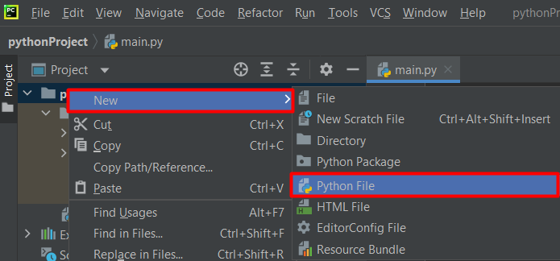
- Enter the name of the file:
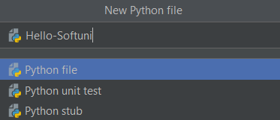
- At the beginning of the file, enter the program code (commands) in the Python language:
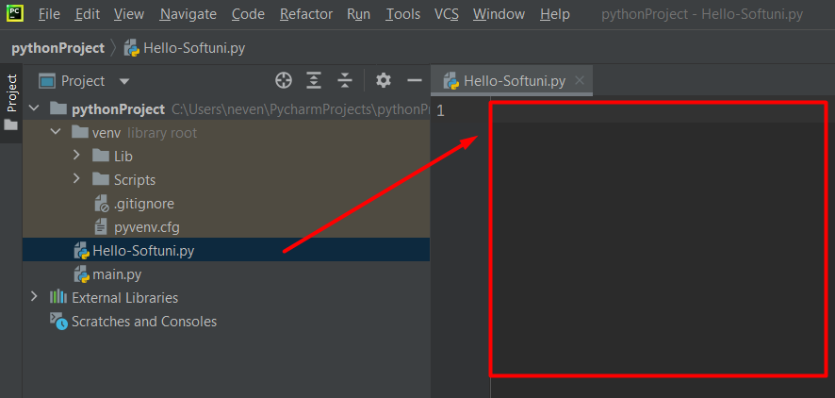
- Write the following program code (command to print the text "Hello SoftUni"):
print('Hello SoftUni')
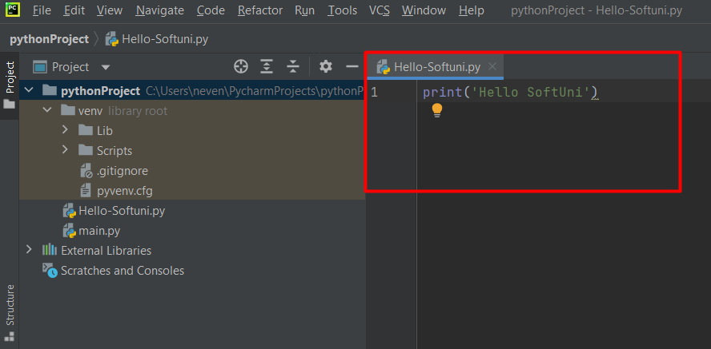
- Run the program by pressing: Alt + Shift + F10 or right click in the code editor area -> Run
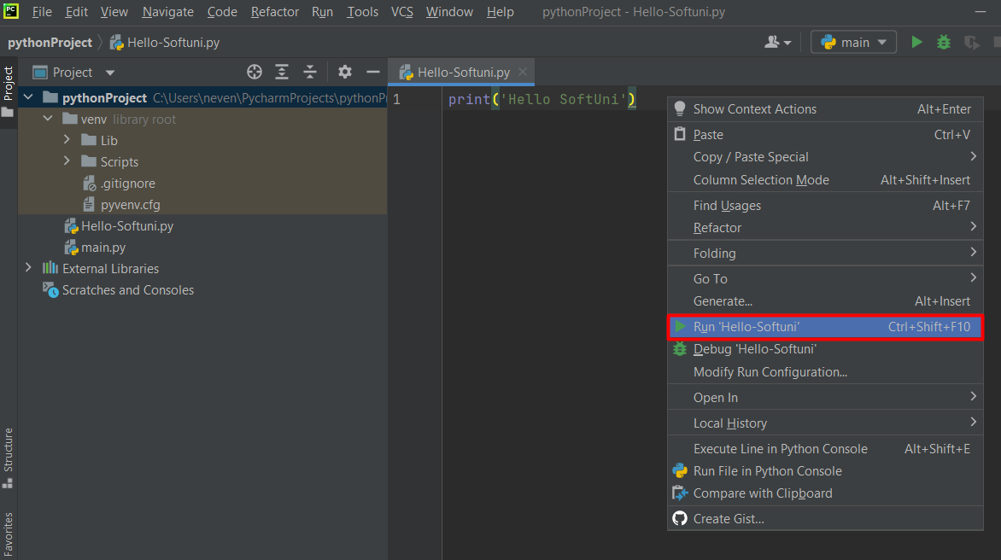

- At the bottom part of the development environment, you will get the following result:
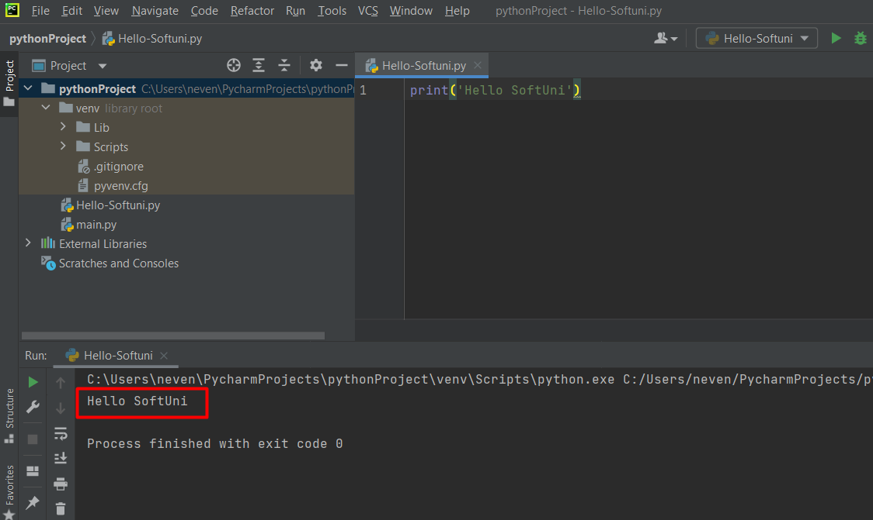

Numbers from 1 to 10
Write a Python console program that prints the numbers from 1 to 10 on separate lines on the console.
- Write 10 print() commands, one after another, to print the numbers from 1 to 10.
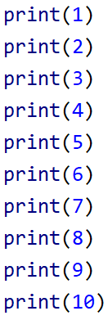
- Test your solution in the Judge system.

Rectangle Area
Write a console program that takes two integers as input (the sides of a rectangle a and b) and calculates the area of the rectangle with these sides.

Examples
Input | Output
5  7 | 35
Input | Output
6  8 | 48

Instructions
- Initialize two variables (a and b) and assign to them the values entered from the console.
- Initialize another variable named area, where you will store the value of the rectangle's area, calculated using the formula a * b.
- Print the calculated result.
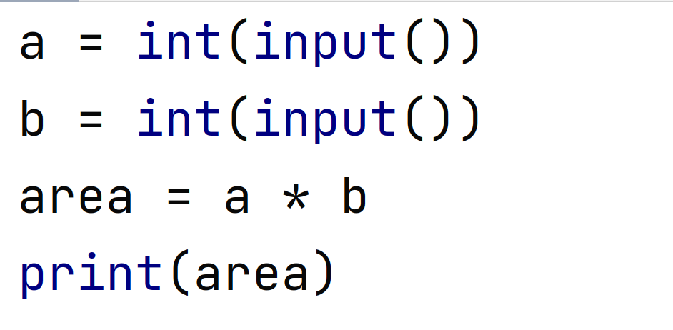

Inches to Centimeters
Write a program that reads a real number from the console and converts it from inches to centimeters. To do this, multiply the inches by 2.54 (1 inch = 2.54 centimeters).

Examples
Input | Output
5 | 12.7
Input | Output
7 | 17.78

Warning: Depending on the regional settings of your operating system, a decimal comma (BG settings) might be used instead of a decimal point (US settings). If the program expects a decimal point and a number with a decimal comma is entered, or vice versa (a decimal point is entered when a decimal comma is expected), an error may occur.
It is recommended to adjust your computer's settings to use a decimal point:
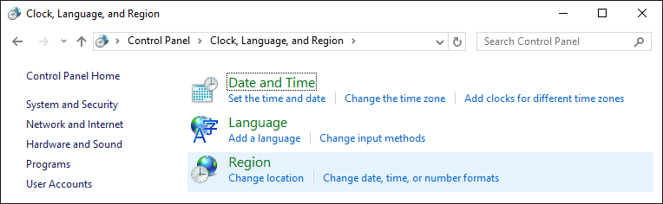
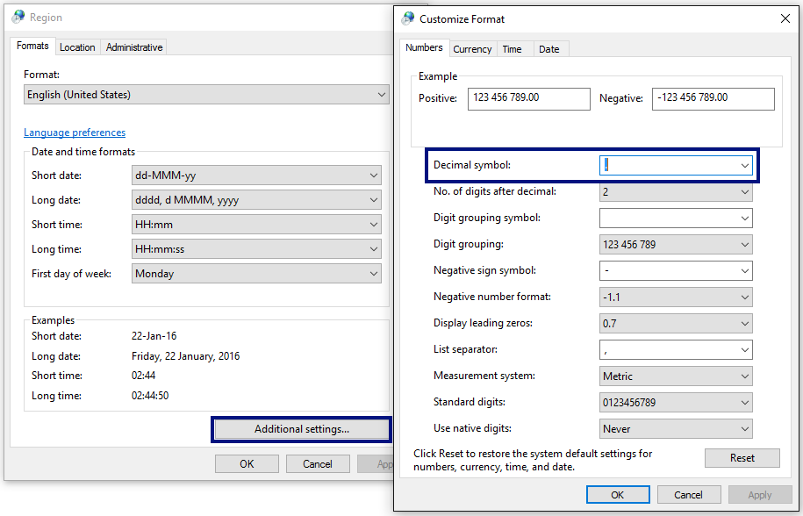

Greeting by Name
Write a program that reads text from the console (a person's name) and prints "Hello, <name>!", where <name> is the entered name from the console.

Instructions
- First, create a new PyCharm file named greeting
- Create the variable name and store in it the name read from the console using the input() function:
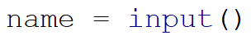
- Output the result on the console by concatenating strings:
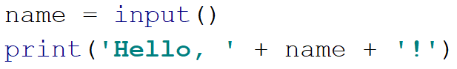

- Run the program using Ctrl + Shift + F10 or right-click -> Run, and test it with different input examples.
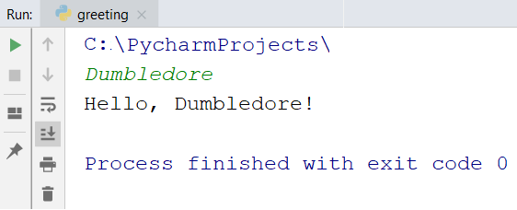

Concatenate Data
Write a program that reads from the console a name, last name, age, and city, and prints the following message:
"You are <firstName> <lastName>, a <age>-years old person from <town>."

Instructions
- Add another file to your current PyCharm project.
- Input the data and store it in variables with appropriate data types:
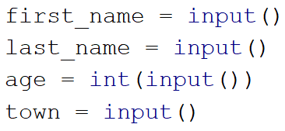
- Output the formatted result:
- Run the program using Ctrl + Shift + F10 and test it with different input examples:
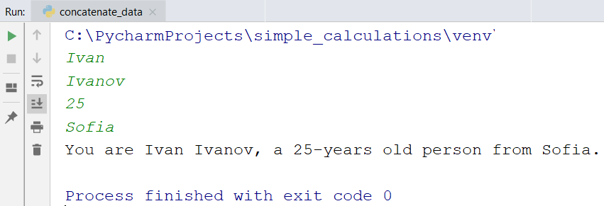

Projects Creation
Write a program that calculates how many hours an architect will need to complete the projects for several construction sites. Creating one project takes three hours.

Input
The console inputs 2 lines:
- The architect's name - text
- The number of projects to be completed - an integer in the range [0 … 100]

Output
The output on the console should be:
- "The architect {the architect's name} will need {needed hours} hours to complete {projects count} project/s."

Examples
Input | Output |  | Input | Output
George  4 | The architect George will need 12 hours to complete 4 project/s. |  | Sanya  9 | The architect Sanya will need 27 hours to complete 9 project/s.

Pet Shop
Write a program that calculates the necessary expenses for purchasing food for dogs and cats. The food is bought from a pet store, where one package of dog food costs 2.50 lv, and one package of cat food costs 4 lv.

Input
The console inputs 2 lines:
- The number of dog food packages – an integer in the range [0…100]
- The number of cat food packages – an integer in the range [0…100].

Output
The output on the console should be:
"{total cost} lv."

Examples
Input | Output |  | Input | Output
5  4 | 28.5 lv. |  | 13  9 | 68.5 lv.

Yard Greening
Bozhidara owns several houses on the Black Sea coast and wants to landscape the yards of some of them, creating a cozy and comfortable environment for her guests. To do so, she has hired a company.
Write a program that calculates the total amount Bozhidara will need to pay the contractor for the project. The price per square meter is 7.61 lv, including VAT. Since her yard is very large, the contractor offers an 18% discount on the final price.

Input
The console reads a single line:
- Square meters to be landscaped – a real number in the range [0.00 … 10000.00]

Output
The console should print two lines:
- "The final price is: {final price of the service} lv."
- "The discount is: {discount} lv."

Examples
Input | Output | Explanations
550 | The final price is: 3432.11 lv.  The discount is: 753.39 lv. | We calculate the cost of landscaping the entire yard:  550 * 7.61 = 4185.50 lv.  We subtract the discount (18% = 0.18) from the total amount:  0.18 * 4185.5 = 753.39 lv.  We calculate the final price of the service:  4185.50 – 753.39 3432.11 lv.
Input | Output | Explanations
150 | The final price is: 936.03 lv.  The discount is: 205.47 lv. | We calculate the cost of landscaping the entire yard:  150 * 7.61 = 1141.50 lv.  We subtract the discount (18% = 0.18) from the total amount:  0.18 * 1141.50 = 205.47 lv.  We calculate the final price of the service:  1141.50 – 205.47 936.03 lv.

